**Zambia country profile**

Published

3 January 2018

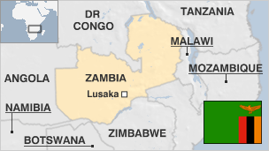

**Zambia, unlike most of its neighbours, has managed to avoid the war and upheaval that has marked much of Africa's post-colonial history, earning itself a reputation for political stability.**

The landlocked country has experienced rapid economic growth over the last decade as Africa's second largest copper producer after the DR Congo. But its over-reliance on copper has made it vulnerable to falling commodity prices.

Zambia also has one of the world's fastest growing populations with the UN projecting that its population will triple by 2050.

But economic growth and massive Chinese investment have failed to improve the lives of most Zambians, with two-thirds still living in poverty.

* Read more profiles by [BBC Monitoring](http://bbc.co.uk/monitoring)

**President: Edgar Lungu**

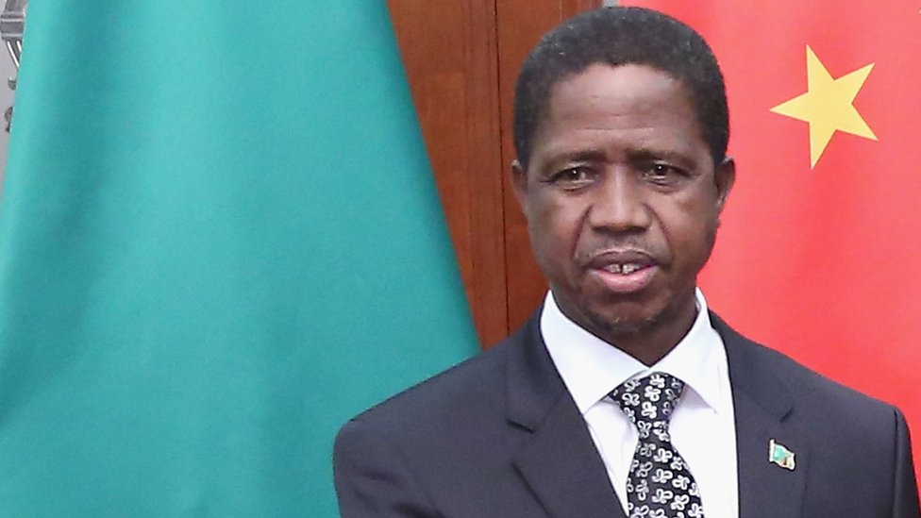image copyrightGetty Images

Edgar Lungu became the sixth president of Zambia in January 2015 after winning a narrow election victory to replace former leader Michael Sata, who died in office.

He gained a new term in August 2016.

A former justice and defence minister from the ruling Patriotic Front, Mr Lungu's toughest challenge has been to turn around a slowing economy hit by a slump in copper prices, the country's biggest export.

A trained lawyer, he has worked in both the state and private sectors.

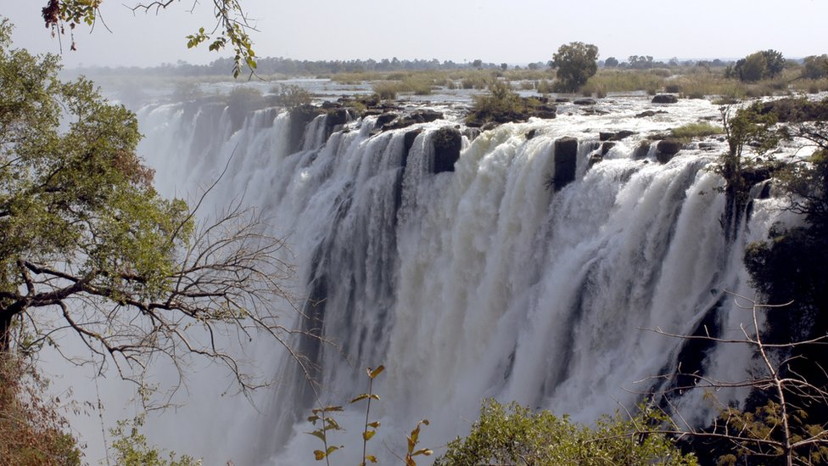image copyrightGetty Images

image captionThe spectacular Victoria Falls are on Zambia's border with Zimbabwe

Radio is the main news source. State-run ZNBC operates alongside private stations.

The government uses financial pretexts or laws on defamation to prosecute journalists, says Reporters Without Borders.

# Zambia profile - Timeline

Published

3 January 2018

**A chronology of key events:**

**12th Century** - Shona people arrive in the area, later establishing the empire of the Mwene Mutapa, which includes southern Zambia.

**16th Century** - Arrival of peoples from Luba and Lunda empires of Zaire to set up small kingdoms.

**Late 18th Century** - Portuguese explorers visit.

**19th Century** - Instability generated by migration as well as slave-trading by Portuguese and Arabs.

**1851** - British missionary David Livingstone visits.

## Copper discovered

**1889** - Britain establishes control over Northern Rhodesia, administering the area using a system of indirect rule which leaves power in the hands of local rulers.

**Late 1920s** - Discovery of copper, which later encourages an influx of European technicians and administrators.

**1953** - Creation of the Federation of Rhodesia and Nyasaland, comprising Northern Rhodesia, Southern Rhodesia (now Zimbabwe) and Nyasaland (now Malawi).

**1960** - UNIP (United National Independence Party) formed by Kenneth Kaunda to campaign for independence and dissolution of federation dominated by white-ruled Southern Rhodesia.

**1963** - Federation dissolved.

**1964** - Independence, with Kaunda as president.

Late 1960s-1970s - Key enterprises nationalised. Private land nationalised in an unsuccessful agricultural improvement programme.

**1972** - Zambia becomes a one-party state, with UNIP as the only legal party.

## Help for rebels

**1975** - Tan-Zam railway opened, providing a link between the Copperbelt to the Tanzanian port of Dar es Salaam, reducing Zambian dependence on Rhodesia and South Africa for its exports.

**1976** - Zambia declares support for the independence struggle in Rhodesia. Zambian help proves crucial to the transition of Rhodesia to an independent Zimbabwe.

**1990** - Food riots.

**1991** - Multi-party constitution adopted. Movement for Multi-party Democracy (MMD) wins elections and its leader, Frederick Chiluba, becomes president.

**1996** - Change to constitution effectively barring Kaunda from future elections. Chiluba re-elected.

**1997** - Attempted coup.

**1999** - A high court sentences 59 soldiers to death after they are found guilty of treason for the failed coup attempt in 1997.

**2000** May - Fighting between Angolan forces and UNITA rebels spills over into Zambian territory.

**2000** July - Environment Minister Ben Mwila expelled from the MMD and dropped from the cabinet after announcing his intention to run for president in 2001.

**2000** December - UN officials estimate that up to 60,000 refugees fleeing fighting in the Democratic Republic of Congo move to Zambia in less than a week.

## Chiluba trouble

**2001** May - Setback for governing Movement for Multi-party Democracy as senior members hive off to create Forum for Democracy and Development. They're opposed to Chiluba's bid for a third term in office.

**2001** July - Paul Tembo, former campaign manager for Chiluba who joined the opposition, is murdered shortly before he is due to testify against three ministers in a high-level corruption case.

**2001** July - Zambia appeals for aid to feed some 2 million people after poor harvests caused by floods and drought.

**2001** July - Final summit of the Organisation of African Unity (OAU), launch of the African Union.

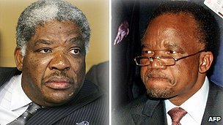image copyrightAFP

image captionLevy Mwanawasa (l) succeeded Frederick Chiluba as president

**2002** January - Levy Mwanawasa is sworn in as president amid opposition protests over alleged fraud in December's presidential elections.

**2002** July - Parliament votes to remove ex-president Frederick Chiluba's immunity from prosecution.

**2002** October - Government says it will not accept genetically modified (GM) maize to help alleviate the severe food shortages facing three million people.

**2003** February onwards - Former president Frederick Chiluba is arrested and charged with corruption. Subsequent long-running trials are dogged by adjournments and procedural problems.

**2003** December - Supreme Court confirms death sentences on 44 soldiers for their role in 1997's failed coup; sentences are later commuted by President Mwanawasa.

**2004** September - Many charges of corruption against former president Frederick Chiluba are dropped, but within hours he is re-arrested on six new charges.

**2005** February - Supreme Court rejects opposition challenge to President Mwanawasa's 2001 election victory, but says ballot had flaws.

## Debt relief

**2005** April - World Bank approves $3.8 billion debt relief package which will write off more than 50% of Zambia's debt.

Around 50 workers killed in explosion at Chinese-owned explosives factory.

**2005** November - President Mwanawasa declares a national disaster and appeals for food aid. He says more than a million Zambians face food shortages owing to drought.

**2006** April - President Mwanawasa suffers a minor stroke. He resumes "light duties" after some weeks and later declares himself fit to run for re-election towards the end of the year.

**2006** September - President Mwanawasa wins a second term.

**2006** October - President announces discovery of oil in the west.

**2007** January - Government launches economic recovery plan which envisages encouraging foreign investment.

**2007** February - Chinese President Hu Jintao inaugurates a huge mining investment zone at the end of a two-day visit. His itinerary is cut short due to planned protests against the alleged exploitation of local workers by Chinese firms.

**2007** May - The High Court in Britain rules that former president Frederick Chiluba and four of his aides conspired to rob Zambia of about $46 million.

**2008** August - President Levy Mwanawasa dies, 59, in a Paris hospital, where he was being treated for the effects of a stroke in June.

**2008** November - Vice-President Rupiah Banda sworn in as president after a narrow election win over the main opposition candidate, Michael Sata, who alleged fraud.

**2009** August - Ex-President Chiluba is cleared of corruption after a six-year trial. The head of the anti-corruption task force is sacked after initiating an appeal against Chiluba's acquittal.

**2010** February - Zambia and China sign mining cooperation agreement and deal to set up joint economic zone.

Supreme Court dismisses application by ex-President Chiluba aimed at preventing government from applying British High Court judgment convicting him of defrauding Zambia of $46m dollars.

**2010** August - Zambia, China agree to build a second hydroelectric power plant on the Kafue River.

**2010** October - Chinese mine managers charged with attempted murder following a multiple shooting at a mine where workers were demonstrating against conditions.

**2010** November - UN updates its Human Development Index, which suggests Zambia is now worse off than in 1970, partly due to AIDS.

**2011** January - Deadly clashes between police and demonstrators agitating for secession of western Zambia, known as Barotseland.

**2011** June - Former President Frederick Chiluba dies.

## Change of government

**2011** September - Michael Sata becomes president.

**2012** August - Chinese mine manager killed during pay protest.

**2013** February - The government takes over the Chinese-owned Collum Coal mine after revoking its licence because of safety lapses.

**2013** March - Former president Rupiah Banda is charged with abuse of power shortly after being stripped of immunity.

**2014** January - Opposition politician Frank Bwalya is charged with defamation after comparing President Sata to a potato in a radio interview.

**2014** June - President Sata goes to Israeli on a ''working holiday" amid rumours about his health.

**2014** October - President Sata dies.

**2015** January - Edgar Lungu becomes president after winning election.

**2015** March - President Lungu has surgery in South Africa. He collapsed at an event the month before.

**2016** April - Rioting and looting following accusations that Rwandans who have fled to Zambia have been involved in ritual killings. President Lungu speaks of his country's collective shame over mob attacks on foreigners.

**2016** August - President Edgar Lungu is re-elected.

**2017** April - Opposition leader Hakainde Hichilema is detained and charged with treason, after his convoy failed to stop for that of President Lungu.

**2017** June - Forty-eight opposition MPs are suspended from parliament for boycotting an address by President Lungu. They they do not accept Mr Lungu as the legitimate winner of last year's election.

**2017** July - President Lungu declares a state of emergency after a market blaze which he describes as sabotage. Critics fear a slide towards authoritarianism.

**2017** August - President Lungu says he wants to introduce compulsory HIV testing to make Zambia free of the disease by 2030.